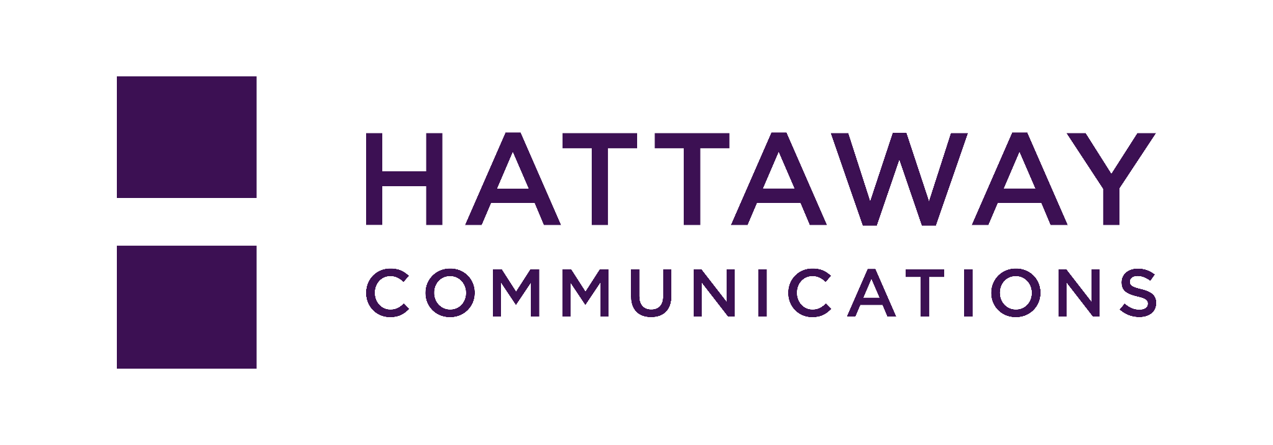


Communicating An Aspirational Vision
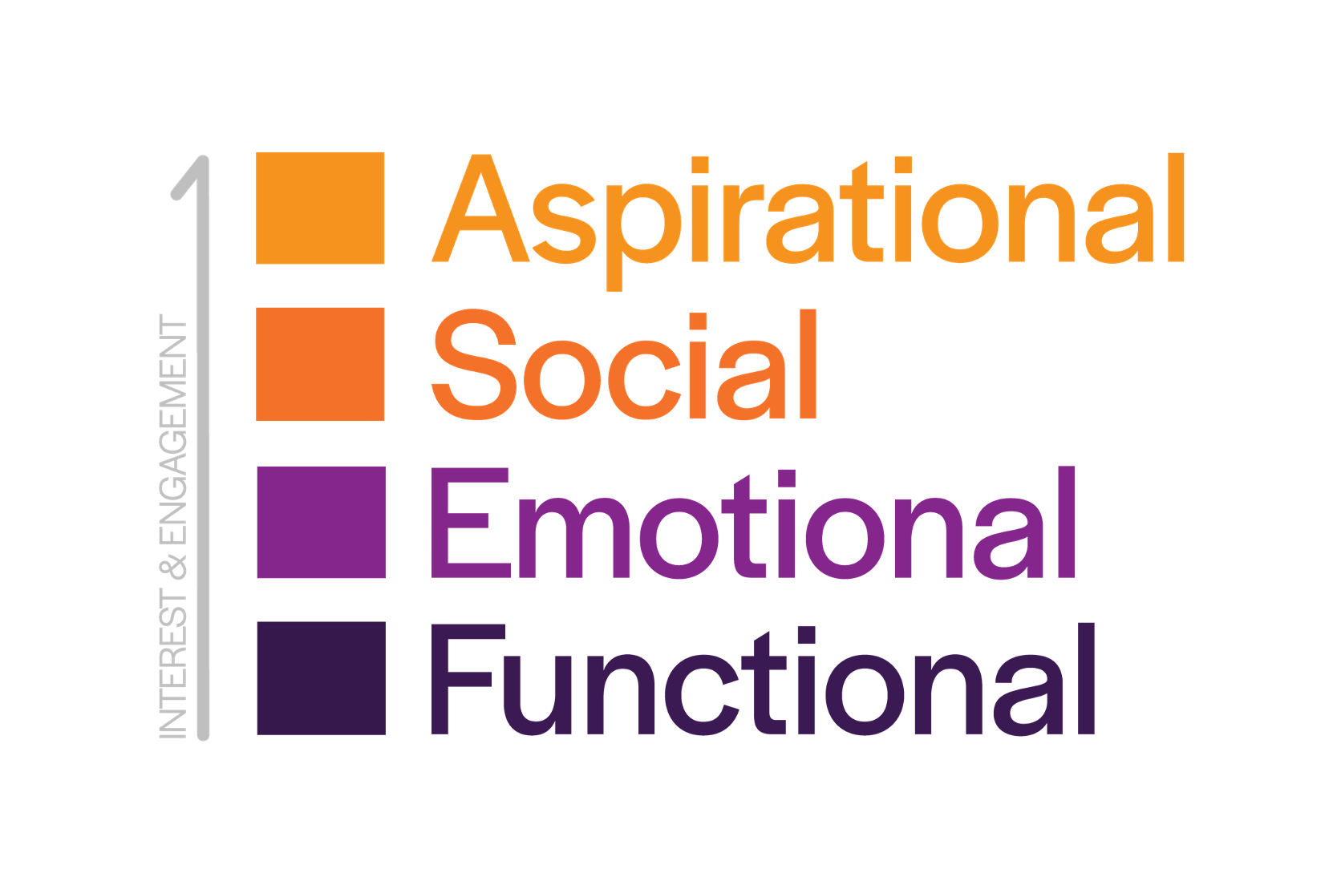
Aspirational: How does our vision help people achieve their highest hopes for themselves and their community?

Social: How does our vision help more people see themselves with a degree or credential?

Emotional: How does our vision inspire people and give them confidence?

Functional: How does our vision make people’s lives better and make communities stronger?

Crafting Audience-first Stories of Value

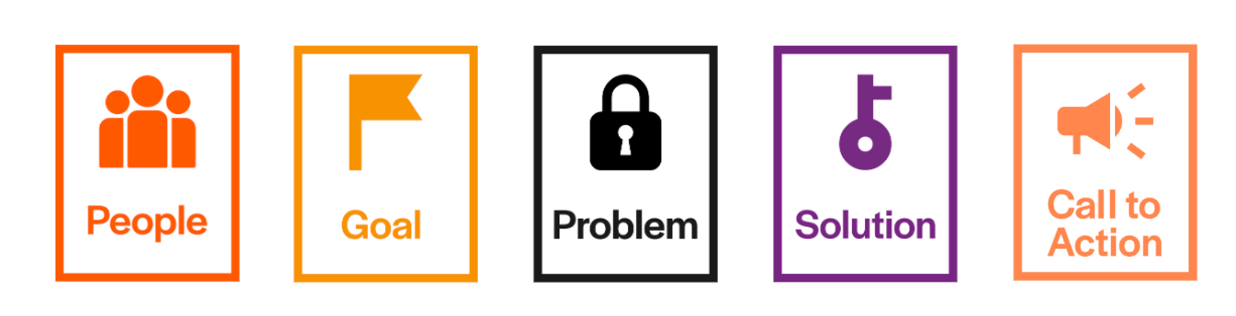

People: Who is your audience?

Goal: What aspirations do you share with them?

Problem: What barriers do they face or needs do they have?

Solution: How do credentials of value help?

Call To Action: How can both you and your audience contribute?

Adapting Communications To Reach Audiences

Strategy: What do you need your audience to know, feel, and do? | Framing: How can you help them achieve their goals? | Tools: What language, stories, and data will matter to them?

